**Reference variable**

A reference variable is a special type of variable which is used to store the address of the object, it can either store the address of the object or null.

Syntax:

Class_name reference_variable = object

Example

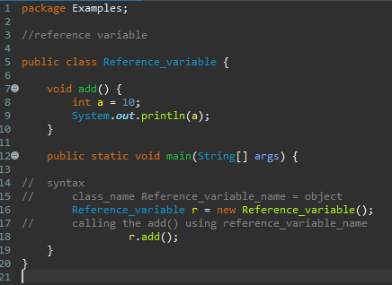

1. Write a program to print the address of the object

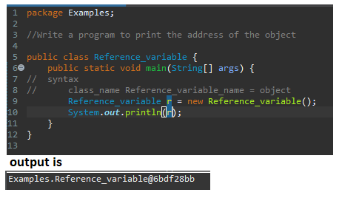

Examples is the package name

Reference_variable is the class name followed by @ hexadecimal numbers

1. Write a program to copy, save the address in new object and print it

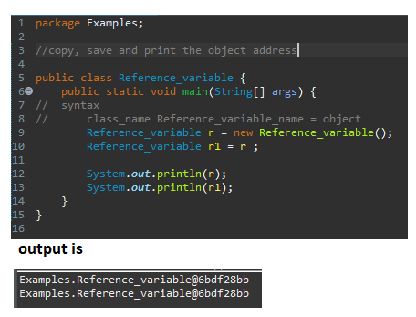

The address will be the same because we are creating reference variable without the object

Practice questions

1. Write a program to find area of a circle using reference variable.
2. Write a program to find square of a number using reference variable with parameters.
3. Write a program to print the address of the object, save the address in a new reference variable.